High Level Design Document
Use case Name: E-Seva – Government Services Application
Developed By : K Devi Srinivas
Abstract :
E-Seva is a centralized digital platform built using Pega to deliver various government services online. It automates processes, enables real-time tracking, and provides a transparent and efficient system aligned with the Digital India initiative.
Scope :
- Citizen user registration and login.
- Apply for various government certificates (e.g., Caste, Income, Birth).
- Upload supporting documents.
- Online payment for services.
- Track application status in real-time.
- SMS and Email notifications.
- Government officer login for application processing.
- Approve/Reject with remarks and SLAs.
- Generate final certificates in PDF.
- Admin dashboard and reporting system.

Design :
Application Name : E-Seva
Organization Name : GovTech India
Application Structure : Implementation
Case Design :
Case Type 1 : Caste Certificate
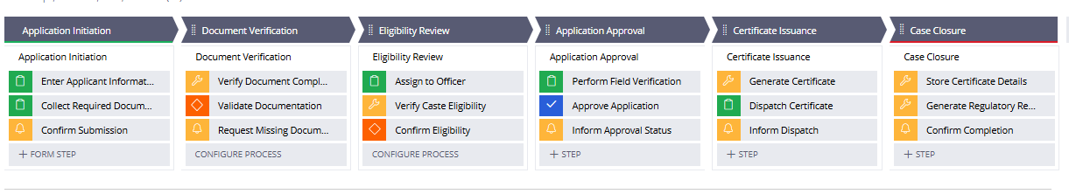

Case Type 2 : Aadhar Update
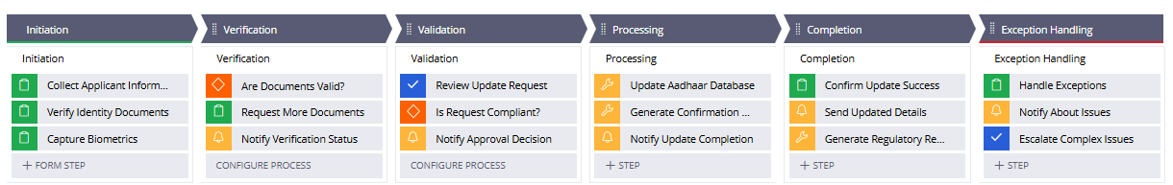
Case Type 3 : Income Certificate
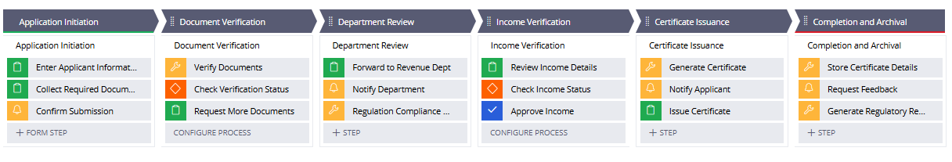
Case Type 4 : Bill Payment
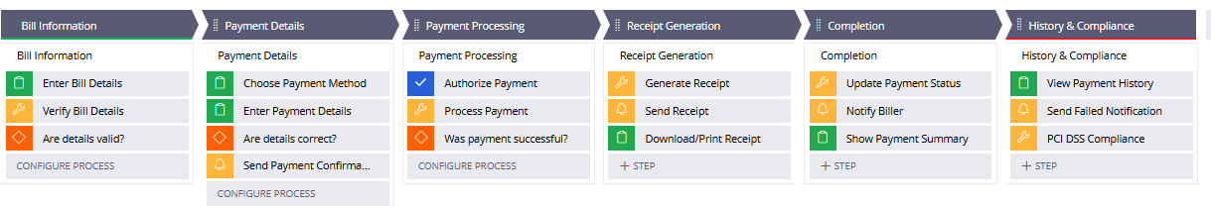

Personas :
Citizen (Web/Mobile Portal)
Channel : Web browser, Mobile browser (responsive design)
Role : Service Request Initiator (End User)
Responsibilities:
- Register and log in using mobile number/email and OTP.
- Browse available government services (e.g., Income Certificate, Caste Certificate).
- Fill out service request forms with required information.
- Upload supporting documents in PDF/JPEG formats.
- Make online payments through the integrated gateway.
- Track the status of their service requests in real-time.
- Receive notifications and alerts via SMS and Email.
- Download approved certificates directly from the portal.

Officer (Web Portal)
Channel: Internal Government Web Portal
Role: Application Reviewer and Approver
Responsibilities:
- Log in securely using assigned credentials.
- View and manage incoming service requests assigned to their department or queue.
- Verify uploaded documents and validate user information.
- Approve or reject requests based on document validity and internal rules.
- Add remarks or comments in case of rejection or clarification.
- Update the request status at each processing stage (e.g., Verified, Approved).
- Ensure requests are resolved within SLA timelines.
- Escalate or reassign requests as needed.

Admin
Channel: Internal Admin Dashboard (Web Only)
Role: Application Supervisor and Report Manager
Responsibilities:
- Monitor overall performance and usage of the E-Seva system.
- View real-time dashboards showing request volumes, pending SLAs, and officer workload.
- Manage operator and access group settings (create/delete/edit users).
- Configure service availability and workflows.
- Generate analytical reports on service usage, processing times, and payment collections.
- Handle escalations and support issues raised by officers or citizens.
- Coordinate with IT or technical teams for integration and updates.
Data & Interfaces :
- Aadhaar Validation via External API
- Payment Gateway Integration
- Document Upload (PDF/JPG)
- SMS/Email Notification Services
Data Object | Attributes | SOR
Citizen | CitizenID, Name, Mobile, Email, Aadhaar Number, Address, DOB | Pega SOR(External)
ServiceRequest | RequestID, ServiceType, RequestDate, Status, OfficerAssigned, Remarks | Pega SOR
Document | DocumentID, FileName, FileType, UploadedBy, LinkedRequestID | Pega SOR
PaymentInfo | PaymentID, Amount, Mode, TransactionDate, Status | Pega SOR(External)
Officer | OfficerID, Name, Department, Designation, WorkQueue | Pega SOR
Notification | NotificationID, MessageType (SMS/Email), ReceiverID, Timestamp, Status | Pega SOR

Enterprise Class Structure Diagram
- Org Layer: GOV-ESEVA
  - Integration Layer : GOV-ESEVA-Int-*
  - Data Layer: GOV-ESEVA-D ata-*
- App Layer (application class)
GOV-ESEVA-APP
    - Data layer :
      - GOV-ESEVA-APP-Data-*
    - Int layer :
      - GOV-ESEVA-APP-Int-*
    - Work layer :
      - GOV-ESEVA-APP-Work-IncomeCertificate
      - GOV-ESEVA-APP-Work-CasteCertificate
      - GOV-ESEVA-APP-Work-AadharUpdate
      - GOV-ESEVA-APP-Work-BillPayment

Header:
- Logo
- Welcome, [Name]
- Logout Button

Portal Design

Citizen Portal UI
Left Navigation Menu:
- Dashboard:
  - View summary of submitted applications, current status, and service timelines
  - Quick links to apply for new services
- Apply for Service:
  - Form to select service type (e.g., Income, Caste Certificate)
  - Dynamic input fields based on selected service
- My Applications:
  - Table/List view showing previously submitted requests, their statuses, and option to view/download certificates
Main Content Area:
- Displays dynamic content based on selected navigation menu item
- Shows forms, status trackers, alerts, and downloadable documents

Government Officer Portal UI
Left Navigation Menu:
- Dashboard:
  - Summary of pending, approved, and rejected applications
  - SLA performance and notifications
- Verify Applications:
  - List of assigned applications
  - View submitted forms and uploaded documents
  - Options to approve, reject, or request re-submission
- Reports:
  - Filter-based report generation by service type, location, or date
  - Export to PDF/Excel
Main Content Area:
- Uses dynamic sections, repeat grids, and document viewers
- Enables inline approval, adding remarks, and history tracking

Admin Portal UI
Left Navigation Menu:
- Admin Dashboard:
  - Metrics: total applications, officer workload, SLA breaches
  - System alerts and downtime logs
- Manage Users:
  - Create/Edit/Delete operators and work groups
  - Assign roles and access groups
- Analytics & Reports:
  - Usage statistics
  - Monthly service trends and department-wise analysis
Main Content Area:
- Displays advanced reports, filters, graphs, and system controls
- Supports administrative actions like configuration updates
Report Design :
Insights / Reports:
- Pending Requests by Department
- Average SLA completion time
- Rejected Requests by Reason
- Applications per Service Type
- Payments Collected per Month

User Details

Access Groups:
- CitizenAccess
- OfficerAccess
- AdminAccess

Work Groups:
- RevenueDeptGroup
- MunicipalDeptGroup
- AdminGroup

Work Queues:
- RevenueOfficerQueue
- CasteOfficerQueue
- GeneralCertificateQueue

Sample Operator IDs:
- citizen123@eseva
- officer.income@eseva
- admin.panel@eseva

